The Bergen School of Architecture (BAS) is happy to announce that we are in search of a new rector for a full-time 4-year fixed term position commencing on August 1st 2021.

We are looking for someone with competence equal to professor or associate professor that is experienced, committed and explorative in their perspectives to lead and nurture an unique learning ecology as it navigates the contemporary evolution of education and professional practice. We are small, we have a history of experimentation and engagement and we have a will to evolve together with each new voice within a collegium.

**APPLICATION DEADLINE: October 1st, 2020**



**ABOUT US**

The Bergen School of Architecture is one of three schools in Norway to offer a Master in Architecture program. It carries a private school status and operates as a foundation, funded mainly through government funding supplemented by student tuition. It offers an accredited 5-year professional study that equals 300 ECTS credits.

The school is situated within a cluster of industrial buildings along the Sandviken waterfront that have been converted to accommodate a learning environment where students and teachers must be able to adapt to unconventional settings and challenging physical conditions. At the same time, the premises offers a huge freedom to facilitate teaching, workshop facilities and other initiatives in large and unconventional spaces. The site offers splendid views towards the sea and is backed by a historic neighbourhood and a mountain range.

The student body consists of approximately 150 students of which 30 are admitted into the first year and approximately 20 international students enter into the 4th year of the master program. Our students are engaged in their teaching environment, pursue initiatives, are committed and hardworking throughout their study.

The teaching team draws from an international pool of architects, artists, engineers and researchers, appointed for various fixed term and temporary positions. In an average year 30 teachers are employed with most combining teaching and practice enabled by the school policy that all teaching positions do not exceed 50% to allow practice to inform the relevance of the teaching. A large portion of the teaching staff live and work throughout Norway and Europe.

While the three first years are mainly taught in Norwegian, the two last years are entirely taught in English. Both English and Norwegian/Scandinavian are working languages within the teaching, while Norwegian is needed to keep updated and in dialogue with local and national authorities.

The administration consists of 6 full-time employees working in close collaboration with the rector on a daily basis. The team oversees a wide range of operational aspects including student services, accounting and financing, bureaucratic and departmental organization, as well as the library and workshop facilities.

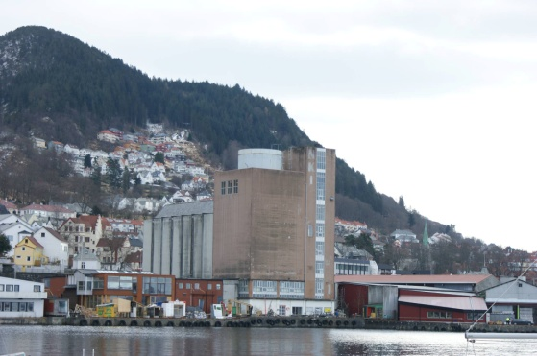

**THEME AND BACKGROUND FOR THE POSITION**

The Bergen School of Architecture was founded in 1986 based on the architectural approach of Open Form, as formulated by Oscar Hansen at the Warsaw Academy of Arts and developed in Norway by his student and the school’s founder, Svein Hatløy. Open Form is open in the sense of allowing and enabling open and participatory architecture. It is also open in the sense that individuals are given the opportunity to create their own situations and their own continuations.

This openness is embodied in the school's conditions: a small, nimble and adaptable institutional structure and a generative and participatory approach to the physical site and buildings the school inhabits. This particular interrelationship and interdependence of conditions forms a unique learning ecology to actively sustain a position of resilience and relevance within a context of ecological, social, political and economic changes.

We value the legacy of Open Form thinking and we welcome an engagement and a challenge of this within and beyond the discourse.

The concept of Sustainability was introduced as a common theme for all teaching in the 2009 strategic plan. For BAS it is important to challenge the sustainability discourse relating to needs, historical contexts, the natural environment, resources, energy and climate, while promoting and supporting a notion of sustainability that is more strongly rooted in the needs of society.

We commit to shape a study that challenges our students through inquiries, agencies and actions that provide experience and question discourse.

We encourage explorative teaching with a research focus, critically engaging in relevant subjects in society. We engage in collaborations with various stakeholders, where challenges are addressed and platforms for funding are sought that can take the projects from ideas to a broader discussion in the public realm through exhibitions, publications, realizations or other means.

Essential parts of our study is situated in the field. We engage with the landscape and the settlements through a mixture of analysis, 1:1 implementations and practical work. The school initiates real, experimental building projects, on site, meant to last. Through these approaches, we commit to be a relevant and experimental part of the profession that elaborates on materials, constructions, use of resources, critical thinking and socio-spatial attitudes.

We share a concern with the public in how we treat our surroundings and we want BAS to legitimize its voice in the broader discussions at the local and regional domain. We want to continue engaging with how architecture and planning is addressing both physical and socio-economic sustainability.

For further info on the strategic direction of the school and details on the teaching approach we refer to the strategy plan, found on our web page

**RECTOR POSITION**

The new rector should be a creative and innovative architect or person with an architecturally relevant background and professional foundation in practice and/or academia and a complementary knowledge of artistic, ecology and theoretical subjects. The position requires a high level of engagement and commitment with the concerns of the school and its trajectory as well as an ability to serve, care and have empathy for the school ethos (position on openness), its pedagogy (broad voices of students, teachers and staff that are afforded an open frame for discussion and agency) and institutional structure (small and adaptable).

The applicant should have documented leadership and teaching experience within architecture and/or urbanism. They should be open minded, actively maintain a national and international professional perspective and contact network and possess the ability to manoeuver and connect various professional cultures.

As the primary leader of BAS, the rector is responsible for the continued development of the school, both in terms of the pedagogy and as a place of work and study. In the coming period the rector will be required to continue the process of renewing the school's government accreditation and strengthening its financial support. The rector is responsible for the management of finances and human resources while reporting to the board. The rector should expect involvement in academic and/or teaching activities yet this will typically form only a small portion of the overall position.

The position is a full-time (100%) 4-year fixed term with the possibility of extension for a second 4-year fixed term. The board will formally hire the new rector. Salary is to be negotiated. Starting date for the position is August 1st 2021.

The new rector must reside in Bergen for the entire duration of the position. We are primarily searching for a Norwegian or Scandinavian speaking candidate yet a well-qualified English-speaking candidate can be considered. In such a case, the candidate must be willing to complete an intensive course in Norwegian upon employment and must be able to use Norwegian as a working language within the first two years of the position.

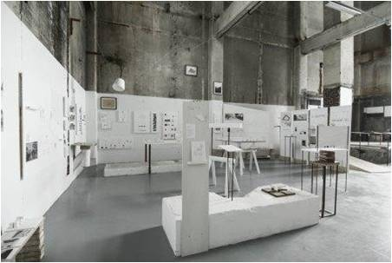

Temporary exhibition of diploma project inside the concrete "cathedral" of BAS

**SUBMISSION**

For this initial round the applicants must submit the following:

Letter of Intent (max 1 A4 page)

Describe your motivation for applying.

We are interested in your understanding of the school: it's legacy, current state, what you consider various challenges, opportunities and possible future trajectory(ies).

Self Presentation (max 1 A4 page)

Describe how your experience can inform your role as rector - how you would translate your knowledge, professional expertise and attitude within such a position.

CV (max five A4 pages)

Include a full summary of education, practice and academic employment as well as a list of relevant work, publications, awards and other info.

**APPLICATION DEADLINE IS OCTOBER 1st 2020**

Digital Submission: adm@bas.org (subject title: rector search + name of applicant)

Post Submission: Bergen School of Architecture, PO Box39, 5841 Bergen, Norway

Please note that all documentation must be in Norwegian (or a Scandinavian language, or English) Interviews and trial lectures/workshops are to be held in either Norwegian and/or English.

**EVALUATION CRITERIA**

Applications will be evaluated according the following criteria:

- Professional qualifications  
 - Administrative experience  
 - Management experience  
 - BAS competence / knowledge  
 - Teaching experience / qualification  
 - Professional network / contacts  
 - Knowledge of / experience with the Ministry of Education / bureaucracy  
 - Professional /Academic production  
 - Language

- Suitability within the context of the school's environment

- Attitude and approach in practice and teaching

In addition to scientific and academic qualifications the appointment procedure will also take into account past practical experience along with administrative and other qualifying experience.

BAS wants its permanent staff to reflect the diversity of the demographics in society. We strive for a gender balance in our teaching staff and encourages females to apply for the positions.

We are open to applicants from a wide range of fields and backgrounds, and are eager to hear how you imagine your position to align with and/or challenge the trajectory of BAS.

**SELECTION PROCESS**

During this initial stage of the selection process candidates can request confidentiality.

An internal committee will evaluate all submitted applications and establish a short list of candidates. Shortlisted candidates without recognized professor/associate professor competence will have the opportunity to receive formal evaluation from an external committee. Following this phase (December 2020 or January 2021) the qualified candidates will be required to submit additional application material including a selection of relevant work/projects and undergo an interview process. In the Spring of 2021, the final selected applicants will be invited to the school for an interview with the internal committee and a test lecture/workshop or similar. Following this process the appointment will be made by the board.

## FURTHER INFORMATION

For more information on BAS's history, professional anchoring, focus areas and more refer to the strategic plan for the period 2015-2025 on our website.

<http://bas.org/novus/upload/tab1/article/small%20Strategiplan%20ferdig%20norsk.pdf>

For further questions please contact the rector committee by the members [www.bas.org](http://www.bas.org) or the committee’s secretary Ingunn Tepstad at [ingunn@bas.org](mailto:ingunn@bas.org).

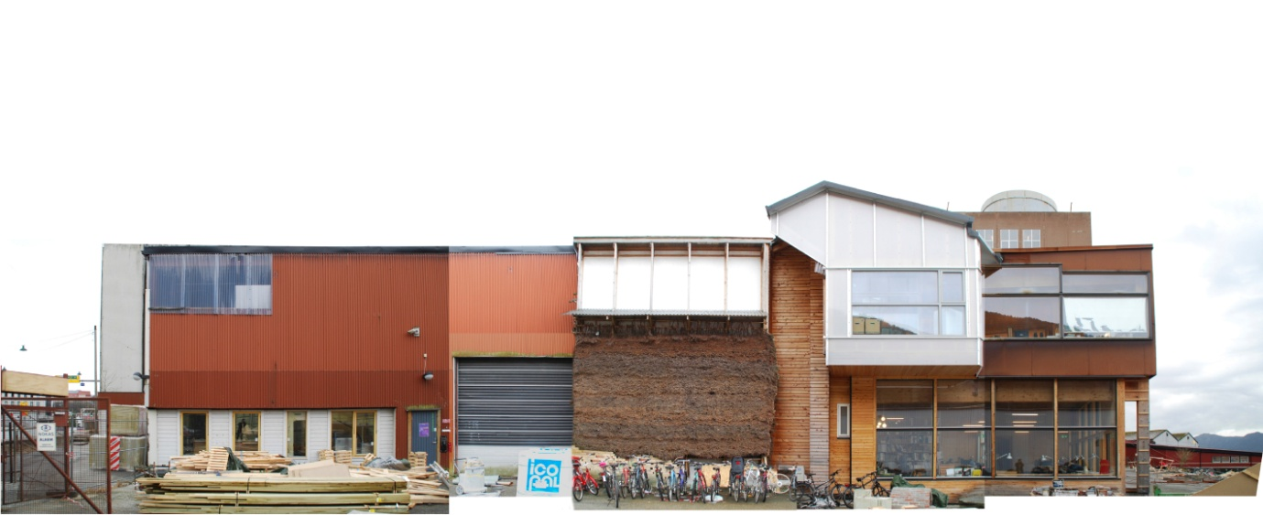

Photo elevation of the main hall building at BAS - a generative architecture, 2015, Angela Posse